**Adding a New Training Program** on the [Eligible Training Provider List](https://joblink.maine.gov/training)

1. [Log in](https://joblink.maine.gov/training) to your ETPL account <https://joblink.maine.gov/training>
2. Go to your training institution’s account.

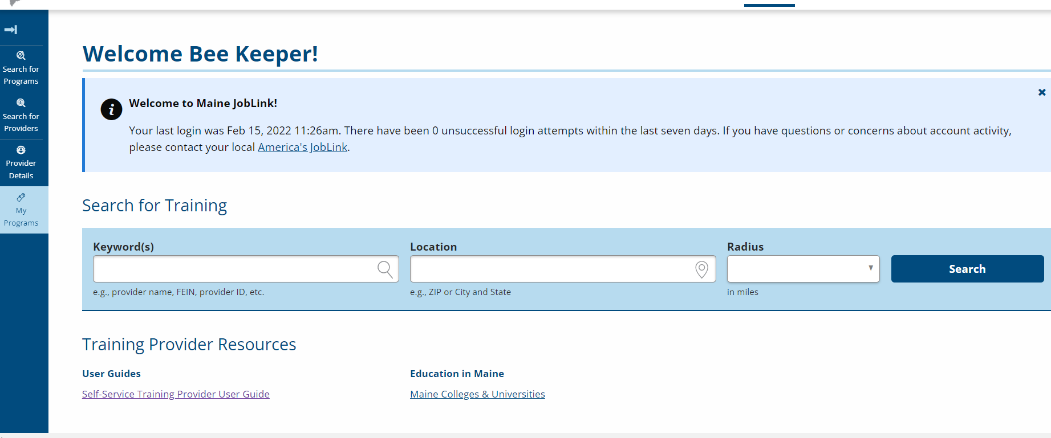

1. Select My Programs from the menu on the left side of the screen. You should see a display of your institution’s programs.

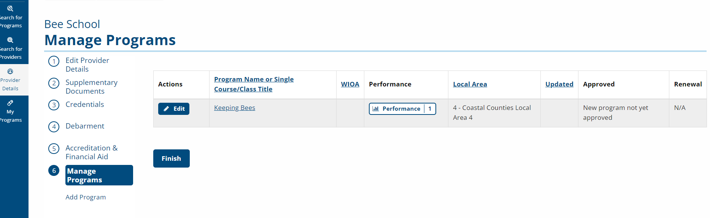

1. Under Manage Programs, select Add Program.

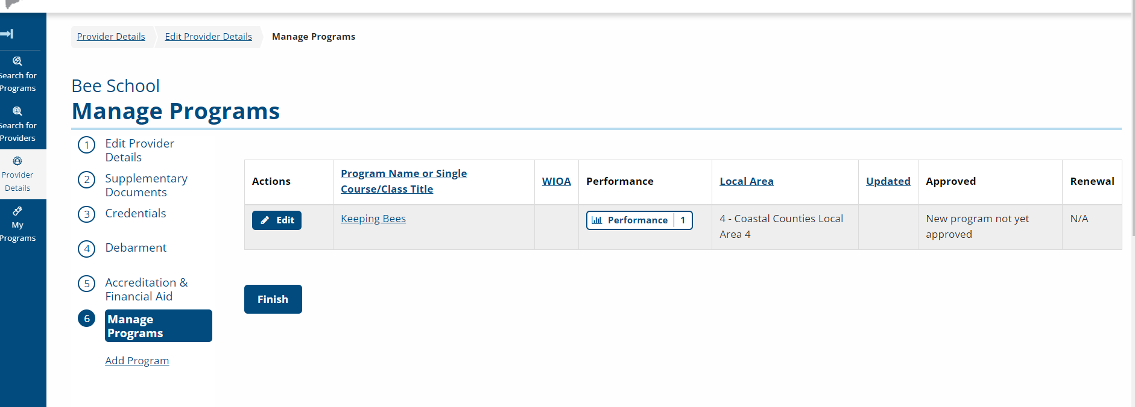

1. You should now see this screen. Follow the prompts to fill in all the fields and select Save.

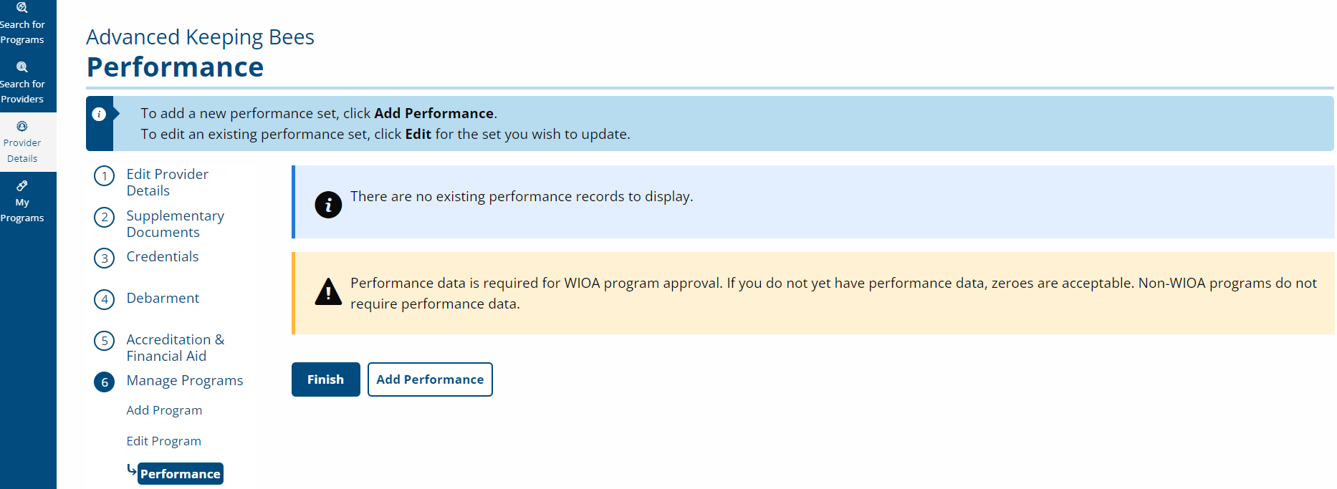

After saving, you will see this screen. If you have performance information on the course, you can fill it in. Otherwise, select Finish.